|  |  |  |  |  |  |  |  |  |  |  |  |  |  |  |  |  |  |
| --- | --- | --- | --- | --- | --- | --- | --- | --- | --- | --- | --- | --- | --- | --- | --- | --- | --- |
| Project Information RUSH REQUEST: | | | | | | | | | | | | | | | | | |
| Date: |  | | Respond By Date: | |  | | Site Drawings Available: | | | |  | | Specifications Available: | | | |  |
| Project Name: | |  | | | | | End Market/Land Use: | | |  | | | | Application: |  | | |
| Project City: | |  | | State: | |  | Project Zip Code: | |  | | |  | | DOT Funding: | |  | |
| Design Status:       % Complete  Permitted  Approved | | | | | | | | Deliverable:  Size/Cost Est.  Proposal  Drawing  Quote | | | | | | | | | |

|  |  |  |  |  |  |  |  |  |  |  |  |  |
| --- | --- | --- | --- | --- | --- | --- | --- | --- | --- | --- | --- | --- |
| Bridge Geometry & Description | | | | | | | | | | | | |
| Style: |  | | Length, Center to Center Bearing (ft): | |  | Width (ft): |  | | Define Width: | |  | |
| Lane Widths (ft): | |  | End Floor Beam: | |  | Truss Finish: |  | | | # Travel Lanes: | |  |
| Clearance Requirement (LxW, ft): | | | |  | Skew Angle: | | |  | | | | |
| Deck: |  | | | | Max Top Deck to Low Steel (in): | | |  | | | | |

|  |  |  |  |  |  |
| --- | --- | --- | --- | --- | --- |
| Loading & Design Requirements | | | | | |
| Live Load (psf): |  | Additional Dead Load (plf): |  | Design Code: |  |

|  |  |  |  |  |  |  |  |  |  |  |  |  |
| --- | --- | --- | --- | --- | --- | --- | --- | --- | --- | --- | --- | --- |
| **Accessories** | | | | | | | | | | | | |
| Guard Rail Placement: |  | | | Roadway Railing: | |  | | | | Sidewalk: | |  |
| # Sidewalks: |  | | Sidewalk Width (ft): | | |  | | | Sidewalks Raised: | | |  |
| Sidewalk Flooring Type: | |  | | | Connection Type: | |  | Sidewalk Railing Type: | | |  | |

|  |
| --- |
| Notes (Assumptions, Challenges, Constraints, etc.) |
|  |
|  |
|  |

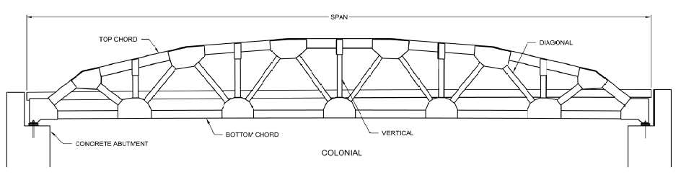

|  |  |  |  |
| --- | --- | --- | --- |
| Contact Information | | | |
| Name: |  | E-mail: |  |
| Company: |  | Phone: |  |
| Address: |  | Fax: |  |

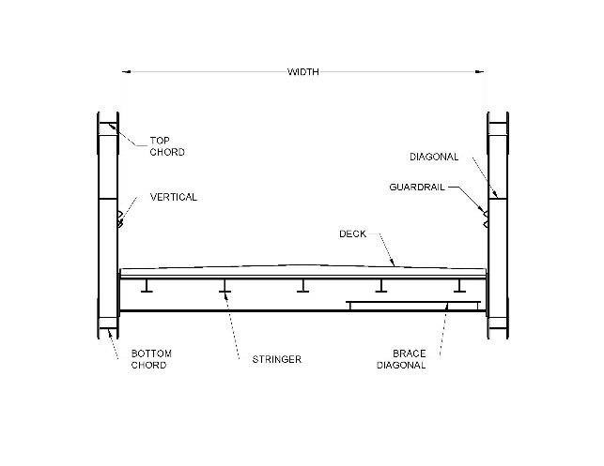



|  |  |  |  |
| --- | --- | --- | --- |
| **PROJECT INFORMATION** | | **LOADING & DESIGN REQUIREMENTS** | |
| End Market / Land Use | Municipal  Golf Course  Timber/Forest  County  Schools  Hospital  Industrial  Railroad  Airport  Mining  DOT  Other (see notes) | Design Code | AASHTO (17th ed)  AASHTO LRFD  Caltrans  State Specifications |
| Application | “Signature” Entrance  Other (see notes) |
| **BRIDGE GEOMETRY & DESCRIPTION** | | **ACCESSORIES** | |
| Style | Colonial  Colonial Flat  Keystone  Capstone  Horizon – Rolled Girder  Faux Truss – Rolled Girder | Roadway Railing | W Beam – Galvanized  W Beam – Weathering  Thrie Beam – Galvanized  Thrie Beam – Weathering  Tubular – Weather  Tubular – Galvanized  Timber  Independent Rail System (IRS)  Concrete Parapet |
| Truss Finish | Weathering Steel  2-Coat Paint  3-Coat Paint  Galvanized  Painted Weathering  Painted Galvanized  Primer Only | Sidewalk | Inside Truss  Outside Truss  None |
| Deck | Corrugated with Asphalt  Corrugated with Concrete  Timber – 3”x 4” SYP  Timber – 3”x 6” SYP  Open Grid  SIP Forms with Concrete  Concrete – No SIP Forms  6”x 14” – Southern Yellow Pine  Concrete Form Deck  Grate  Precast Plank  Fiber Reinforced Plastic  Other (see notes) | Sidewalk Flooring Type | Corrugated with Asphalt  Corrugated with Concrete  Timber – 3”x 4” SYP  Timber – 3”x 6” SYP  Open Grid  SIP Forms with Concrete  Concrete – No SIP Forms  6”x 14” – Southern Yellow Pine  Concrete Form Deck  Grate  Precast Plank  Fiber Reinforced Plastic  Other (see notes) |
| Sidewalk Railing Type | Vertical Pickets  Horizontal Angles  Wire Mesh  Multiline Horizontal Timber |